CSD-4464 Programming Java EE

WEEK 8

Assignment 4

Date: 18th March 2022

Output

Group E Members:

Anirudh Vallampatla C0796429

Meghana Kondaveeti C0784302

Srikanth Ajith Kumar Yarram C0793406

Vishal Kumar C0793379

Yamini Rathod C0796390

Member Added

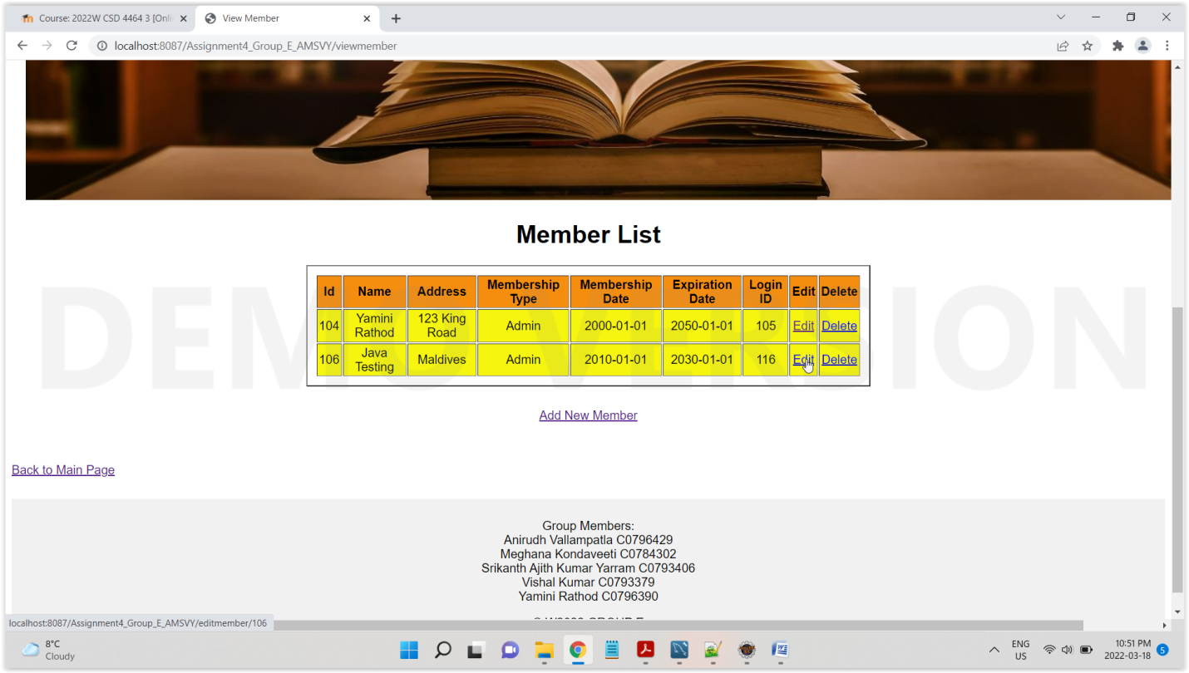

Edit Member

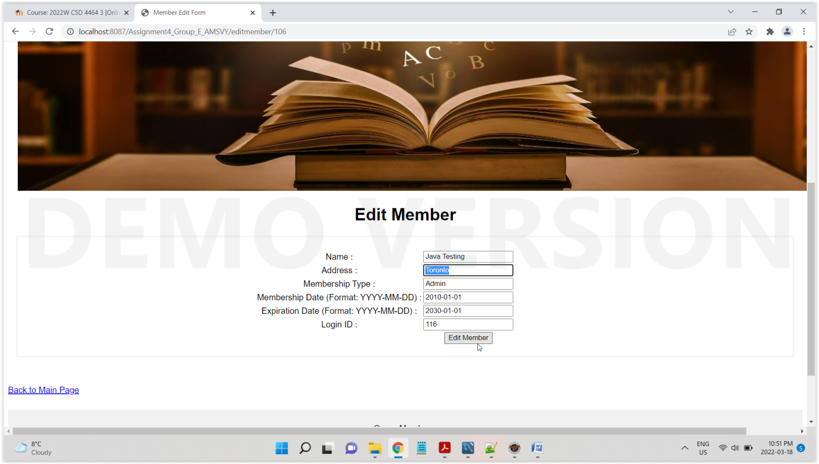

Changed Address

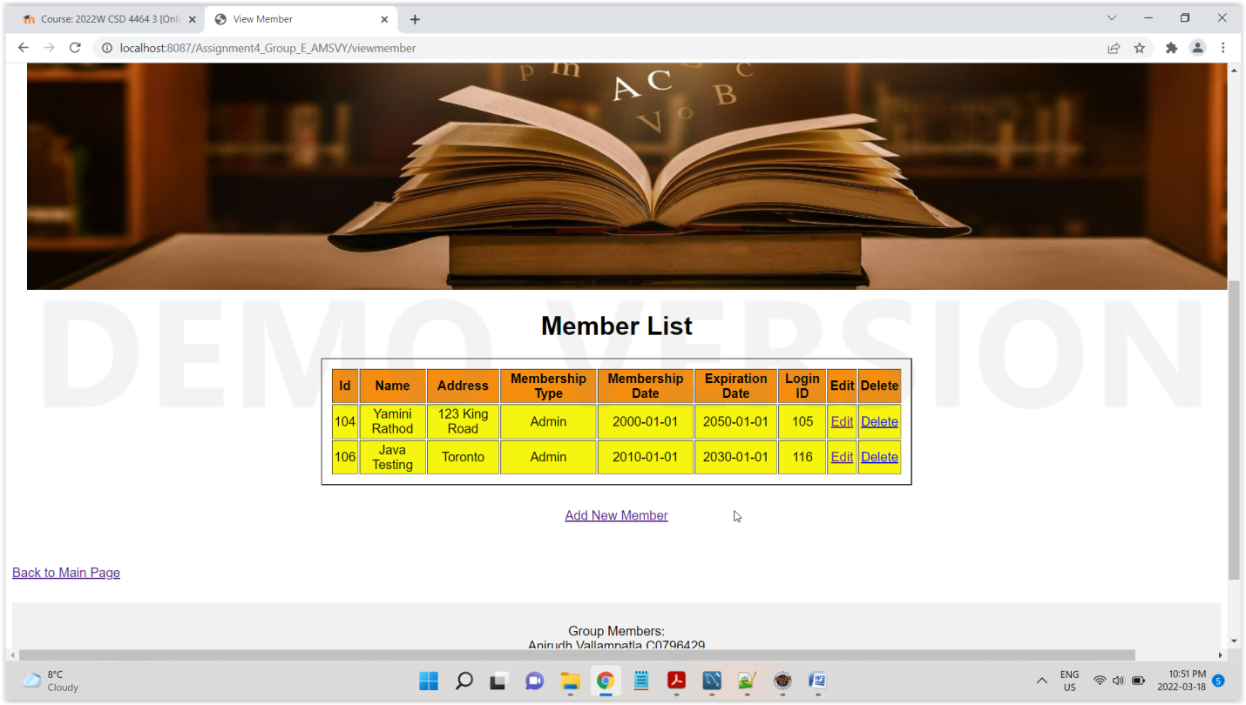

Delete Member with id 106

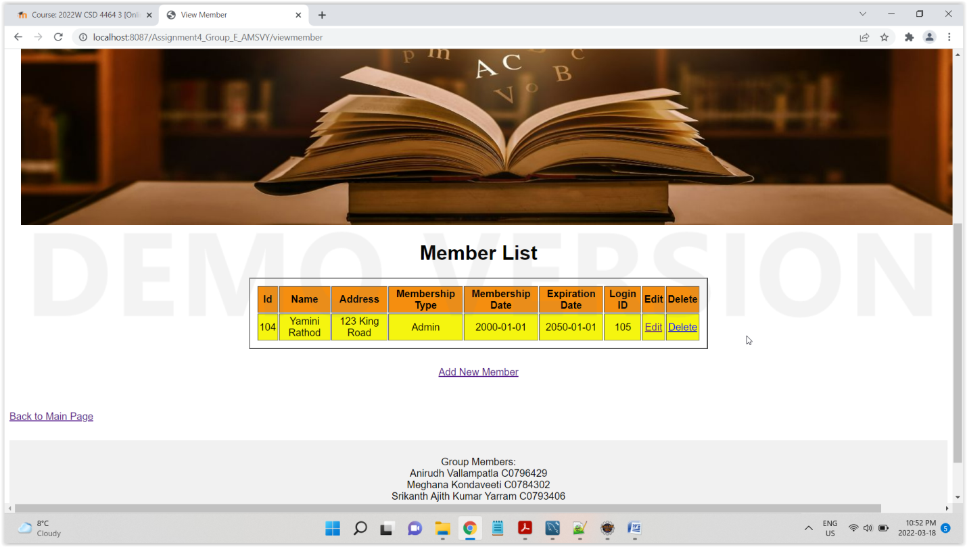

Add Publisher

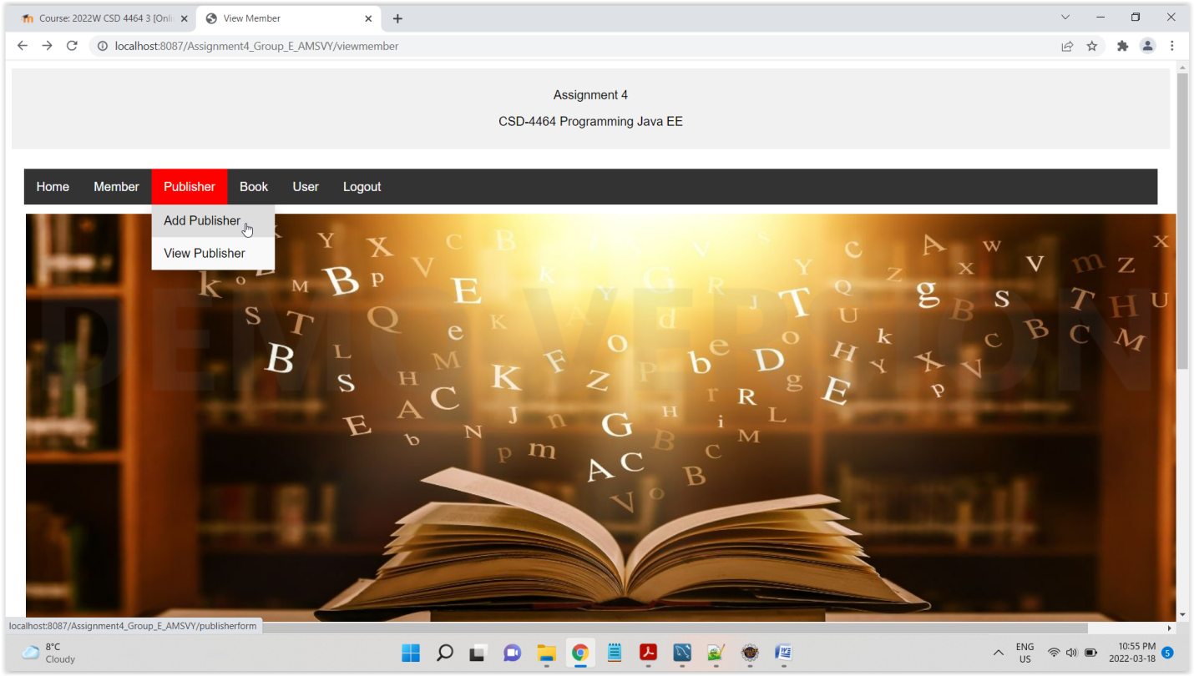

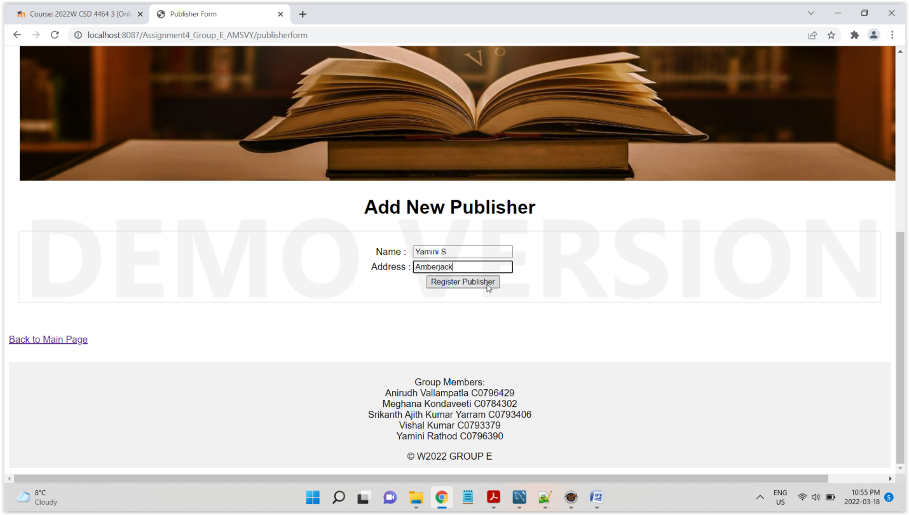

Publisher Added

